3.3.4.3.4 Tessellation
# Source: AI Source: Provided by: [Data Path: Persons Table -> ID Column: 1, Name_En Column: Motasem Essam] -> From: [ChatGPT] on [7/25/2026]
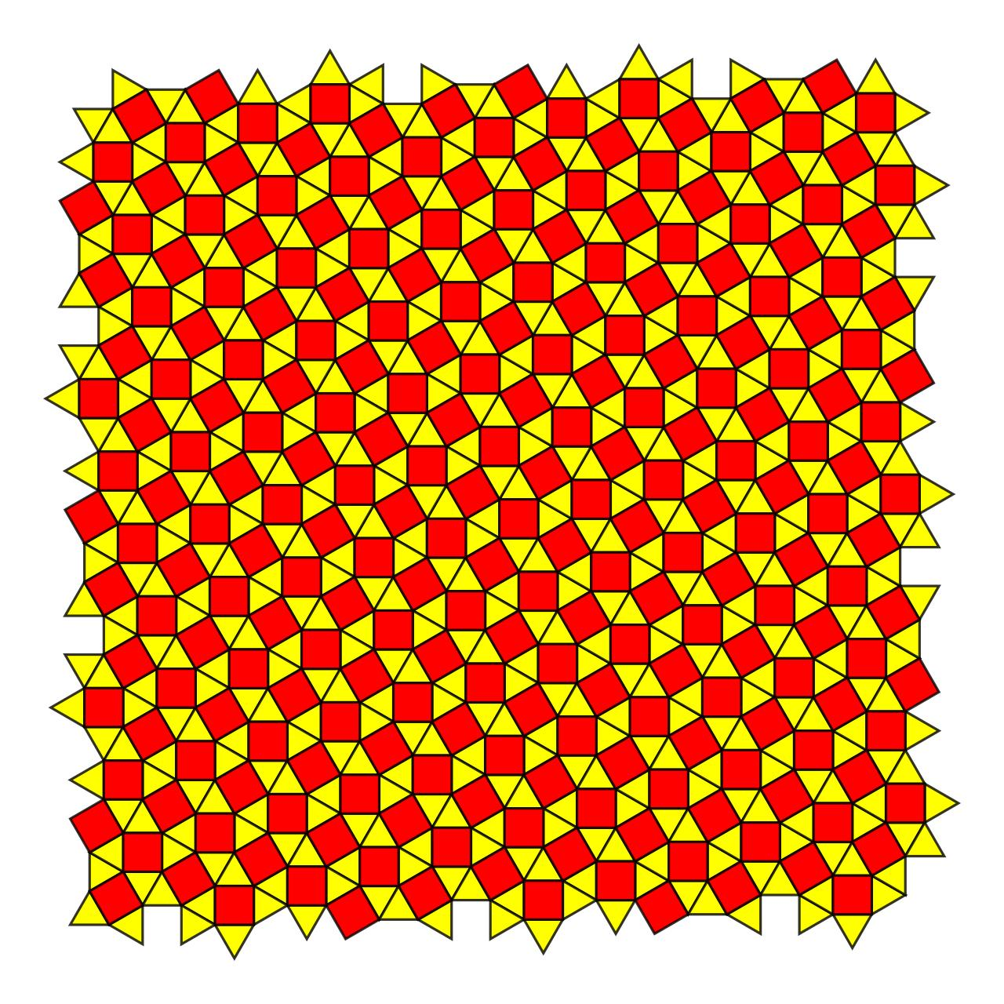
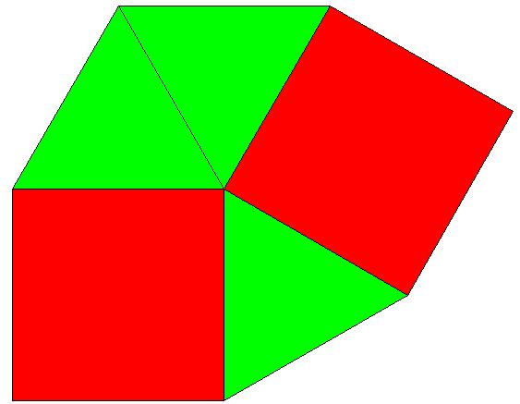
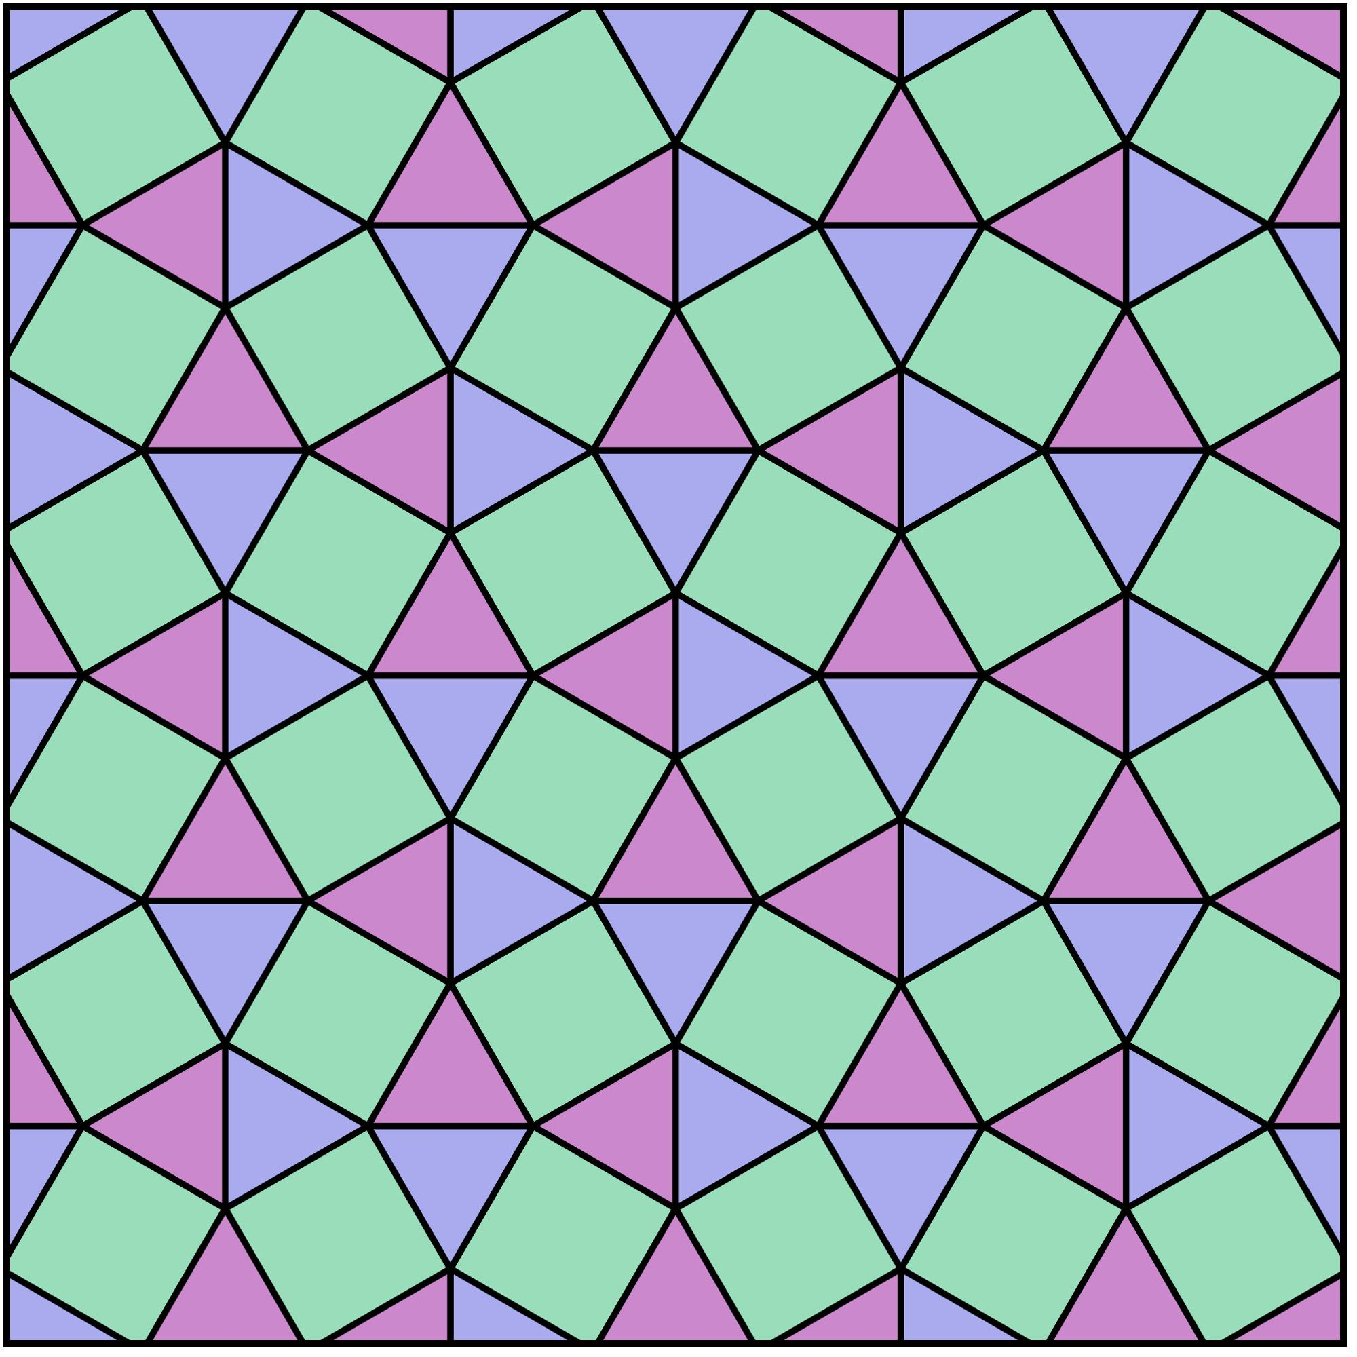

Definition
# Source: AI Source: Provided by: [Data Path: Persons Table -> ID Column: 1, Name_En Column: Motasem Essam] -> From: [ChatGPT] on [7/25/2026]
The 3.3.4.3.4 Tessellation is a semi-regular (Archimedean) tessellation of the Euclidean plane composed of equilateral triangles and squares, arranged so that the same sequence of polygons occurs around every vertex.
Its vertex configuration is:
$$\boxed{3.3.4.3.4}$$
This means that, around every vertex, the polygons occur in the cyclic order:
Triangle → Triangle → Square → Triangle → Square

Classification
# Source: AI Source: Provided by: [Data Path: Persons Table -> ID Column: 1, Name_En Column: Motasem Essam] -> From: [ChatGPT] on [7/25/2026]
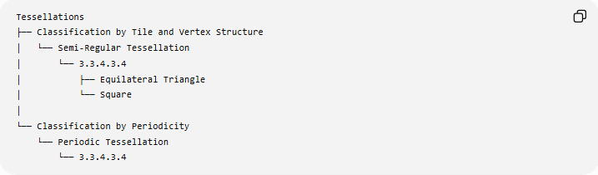
Tessellations
├── Classification by Tile and Vertex Structure
│ └── Semi-Regular Tessellation
│ └── 3.3.4.3.4
│ ├── Equilateral Triangle
│ └── Square
│
└── Classification by Periodicity
└── Periodic Tessellation
└── 3.3.4.3.4
Therefore:
$$\boxed{\text{3.3.4.3.4 is Semi-Regular and Periodic}}$$

Fundamental Elements
# Source: AI Source: Provided by: [Data Path: Persons Table -> ID Column: 1, Name_En Column: Motasem Essam] -> From: [ChatGPT] on [7/25/2026]
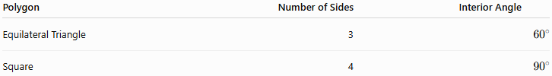
Polygon | Number of Sides | Interior Angle
Equilateral Triangle | 3 | $${60}^{∘}$$
Square | 4 | $${90}^{∘}$$
Each vertex is surrounded by:
- 3 equilateral triangles
- 2 squares

Vertex Angle Verification
# Source: AI Source: Provided by: [Data Path: Persons Table -> ID Column: 1, Name_En Column: Motasem Essam] -> From: [ChatGPT] on [7/25/2026]
At each vertex:
$${60}^{∘}+{60}^{∘}+{90}^{∘}+{60}^{∘}+{90}^{∘}={360}^{∘}$$
Therefore:
$$\boxed{{360}^{∘}}$$
The polygons completely fill the plane around every vertex without gaps or overlaps.

Vertex Configuration
# Source: AI Source: Provided by: [Data Path: Persons Table -> ID Column: 1, Name_En Column: Motasem Essam] -> From: [ChatGPT] on [7/25/2026]
The notation
$$\boxed{3.3.4.3.4}$$
records the number of sides of the polygons encountered in cyclic order around a vertex.
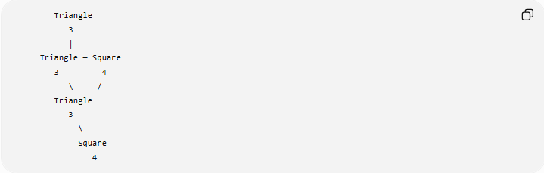
Triangle
3
│
Triangle ─ Square
3 4
\ /
Triangle
3
\
Square
4
The order matters.

Equivalent Compact Notation
# Source: AI Source: Provided by: [Data Path: Persons Table -> ID Column: 1, Name_En Column: Motasem Essam] -> From: [ChatGPT] on [7/25/2026]
The configuration can also be written as:
$$\boxed{3^{3}{.4}^{2}}$$
This indicates:
- $3^{3}$→ three triangles
- $4^{2}$→ two squares
However, $3^{3}{.4}^{2}$does not by itself show their cyclic arrangement as explicitly as $3.3.4.3.4$.

Why It Is Semi-Regular
# Source: AI Source: Provided by: [Data Path: Persons Table -> ID Column: 1, Name_En Column: Motasem Essam] -> From: [ChatGPT] on [7/25/2026]
It satisfies the defining characteristics of a semi-regular tessellation:
- All tiles are regular polygons.
- More than one polygon type is used.
- The same vertex configuration occurs at every vertex.
- The polygons meet edge-to-edge.
- There are no gaps or overlaps.
Thus:
$$\boxed{\text{Semi-Regular Tessellation}}$$

Why It Is Not Regular
# Source: AI Source: Provided by: [Data Path: Persons Table -> ID Column: 1, Name_En Column: Motasem Essam] -> From: [ChatGPT] on [7/25/2026]
A regular tessellation uses only one type of regular polygon.
The $3.3.4.3.4$tessellation uses:
- Equilateral triangles
- Squares
Therefore:
$$\boxed{\text{Not a Regular Tessellation}}$$

Symmetry
# Source: AI Source: Provided by: [Data Path: Persons Table -> ID Column: 1, Name_En Column: Motasem Essam] -> From: [ChatGPT] on [7/25/2026]
The tessellation has:
- Translational symmetry
- Rotational symmetry
- Reflection symmetry
- Repeating fundamental units
Consequently, it is a periodic tessellation.

Comparison with 3.3.3.4.4
# Source: AI Source: Provided by: [Data Path: Persons Table -> ID Column: 1, Name_En Column: Motasem Essam] -> From: [ChatGPT] on [7/25/2026]
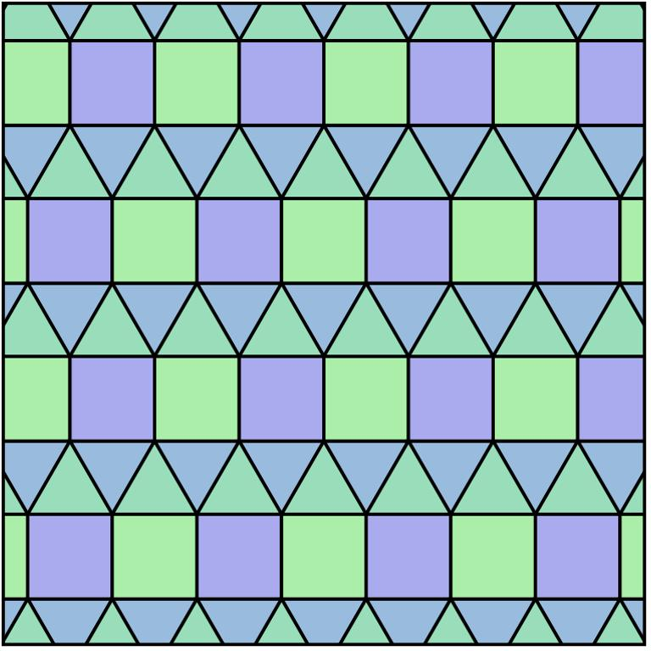
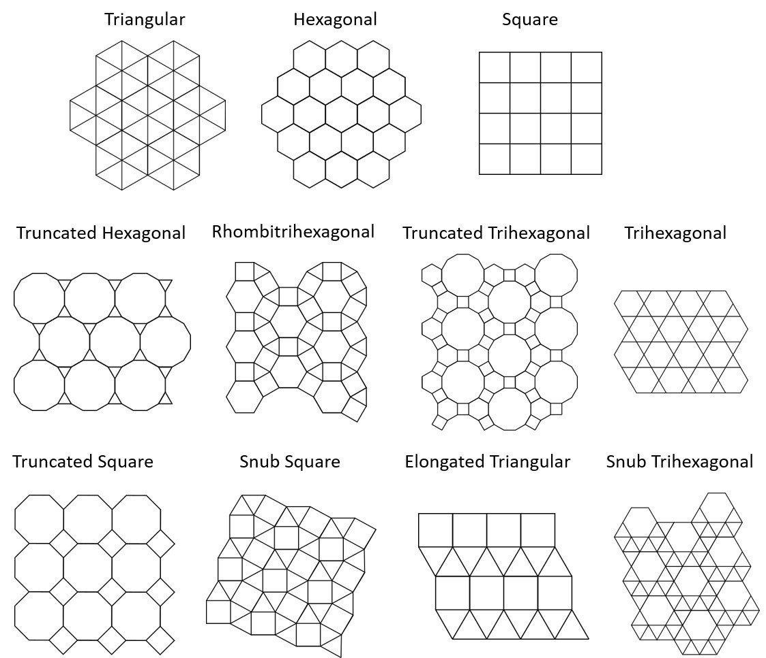
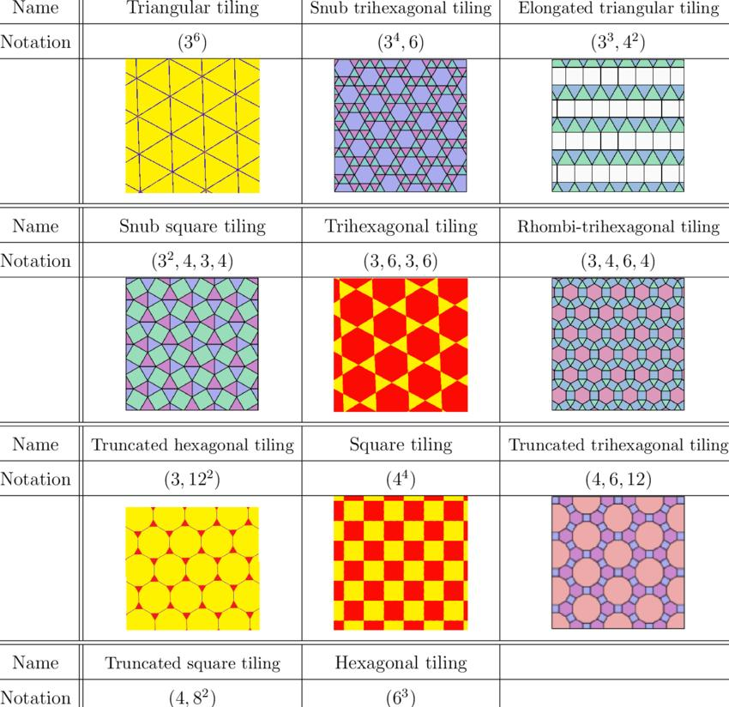
Both configurations use three triangles and two squares, but their cyclic arrangements differ.
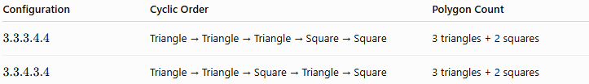
Configuration | Cyclic Order | Polygon Count
$$3.3.3.4.4$$ | Triangle → Triangle → Triangle → Square → Square | 3 triangles + 2 squares
$$3.3.4.3.4$$ | Triangle → Triangle → Square → Triangle → Square | 3 triangles + 2 squares
Therefore:
$$\boxed{3.3.3.4.4≠3.3.4.3.4}$$
They are distinct semi-regular tessellations because their vertex configurations are different.

Relationship to the Eight Semi-Regular Tessellations
# Source: AI Source: Provided by: [Data Path: Persons Table -> ID Column: 1, Name_En Column: Motasem Essam] -> From: [ChatGPT] on [7/25/2026]
The $3.3.4.3.4$configuration is one of the 8 Archimedean (semi-regular) tessellations:
Semi-Regular Tessellations
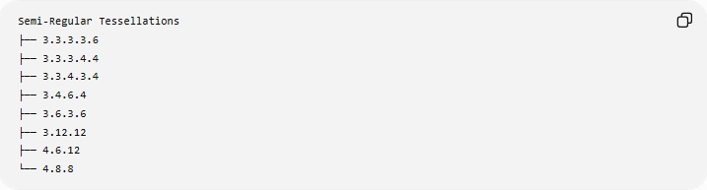
├── 3.3.3.3.6
├── 3.3.3.4.4
├── 3.3.4.3.4
├── 3.4.6.4
├── 3.6.3.6
├── 3.12.12
├── 4.6.12
└── 4.8.8

Examples

Example 1 — Identify the polygons
# Source: AI Source: Provided by: [Data Path: Persons Table -> ID Column: 1, Name_En Column: Motasem Essam] -> From: [ChatGPT] on [7/25/2026]
For:
$$3.3.4.3.4$$
the tiles are:
$$\boxed{3\text{-gon},3\text{-gon},4\text{-gon},3\text{-gon},4\text{-gon}}$$
Since the polygons are regular:
- 3-gons → equilateral triangles
- 4-gons → squares

Example 2 — Verify the vertex
# Source: AI Source: Provided by: [Data Path: Persons Table -> ID Column: 1, Name_En Column: Motasem Essam] -> From: [ChatGPT] on [7/25/2026]
$$3\left({60}^{∘}\right)+2\left({90}^{∘}\right) \\ ={180}^{∘}+{180}^{∘} \\ =\boxed{{360}^{∘}}$$
Thus the configuration can tessellate the plane.

Key Properties
# Source: AI Source: Provided by: [Data Path: Persons Table -> ID Column: 1, Name_En Column: Motasem Essam] -> From: [ChatGPT] on [7/25/2026]
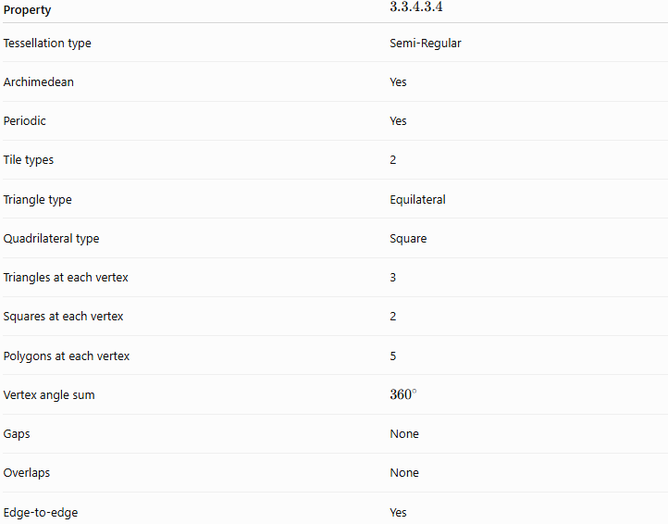
Property | $$3.3.4.3.4$$
Tessellation type | Semi-Regular
Archimedean | Yes
Periodic | Yes
Tile types | 2
Triangle type | Equilateral
Quadrilateral type | Square
Triangles at each vertex | 3
Squares at each vertex | 2
Polygons at each vertex | 5
Vertex angle sum | $${360}^{∘}$$
Gaps | None
Overlaps | None
Edge-to-edge | Yes

Key Points
# Source: AI Source: Provided by: [Data Path: Persons Table -> ID Column: 1, Name_En Column: Motasem Essam] -> From: [ChatGPT] on [7/25/2026]
- $3.3.4.3.4$is one of the 8 semi-regular tessellations.
- It uses equilateral triangles and squares.
- Every vertex has 3 triangles and 2 squares.
- The cyclic order is specifically:
$$\boxed{3→3→4→3→4}$$
- The angles around each vertex total ${360}^{∘}$.
- It is semi-regular, not regular.
- It is also periodic.
- It is distinct from $3.3.3.4.4$because the cyclic order around the vertex is different.

Conclusion
# Source: AI Source: Provided by: [Data Path: Persons Table -> ID Column: 1, Name_En Column: Motasem Essam] -> From: [ChatGPT] on [7/25/2026]
The 3.3.4.3.4 tessellation is a semi-regular Archimedean tessellation formed by repeating equilateral triangles and squares. Its defining feature is the uniform vertex configuration
$$\boxed{3.3.4.3.4}$$
where three triangles and two squares meet in a specific cyclic order, completely filling the plane around every vertex.

